In situ X-ray absorption spectroscopic studies of magnetic Fe@Fe_{x}O_{y}/Pd nanoparticle catalysts for hydrogenation reactions
Yali Yaoª, Stefano Rubino^{b}, Byron D. Gates^{b}, Robert W. J. Scott^{a,}*, Yongfeng Hu^{c,}*
ª Department of Chemistry, 110 Science Place, University of Saskatchewan, Saskatoon, SK S7N 5C9, Canada
^{b} Department of Chemistry and 4D LABS, Simon Fraser University, Burnaby, BC V5A 1S6, Canada
^{c} Canadian Light Source, University of Saskatchewan, Saskatoon, SK S7N 2V3, Canada

* Corresponding author. Tel: +1 3066573722
E-mail addresses: robert.scott@usask.ca (R. W. J. Scott), yongfeng.hu@lightsource.ca (Y. Hu)

Fig. S1. Low-magnification TEM images of the 50:1 Fe@Fe_{x}O_{y}/Pd NPs.

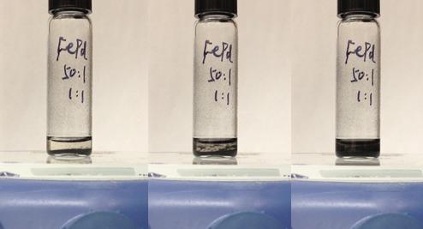
0s 10s 20s
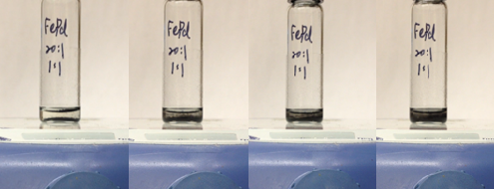
0s 20s 40s 60s
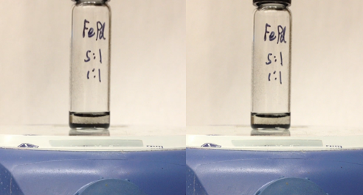
0s 60s
Fig. S2. The comparison of stirring ability of different molar ratios of Fe@Fe_{x}O_{y}/Pd NPs on a magnetic stirrer at a speed of 1600 rpm.
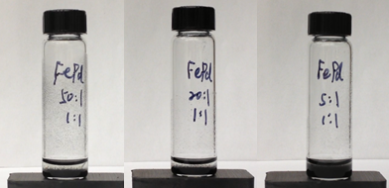
Fig. S3. The comparison of magnetic recycling ability of different molar ratios of Fe@Fe_{x}O_{y}/Pd NPs on a magnet after 9s.

50:1 Fe@Fe_{x}O_{y}/Pd NPs
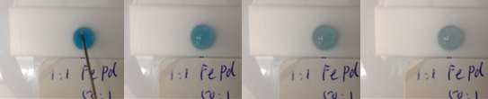
0s 10s 20s 25s
20:1 Fe@Fe_{x}O_{y}/Pd NPs
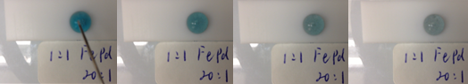
0s 10s 20s 25s
Without Fe@Fe_{x}O_{y}/Pd NPs
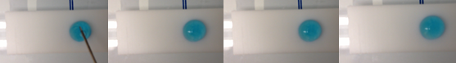
0s 10s 20s 25s
Fig. S4. The comparison of the hydrogenation of methylene blue by NaBH₄ in smaller volume liquid droplet with and without the stirring of Fe@Fe_{x}O_{y}/Pd NPs.

Fig. S5. Reaction rate versus temperature for 20:1 Fe@Fe_{x}O_{y}/Pd NPs (0.0050 mmol based on Pd content) to catalyze the hydrogenation of 2-methyl-3-buten-2-ol (1.9 mmol) in 5.0 mL water while stirring with a stir-bar.

Fig. S6. Reaction rate versus temperature for 5:1 Fe@Fe_{x}O_{y}/Pd NPs (0.0050 mmol based on Pd content) to catalyze the hydrogenation of 2-methyl-3-buten-2-ol (1.9 mmol) in 5.0 mL water, with no stir-bar.

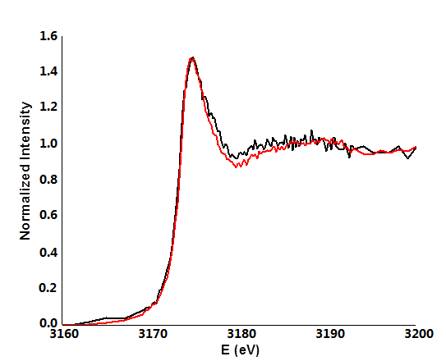 Fig. S7. The Pd L-edge XANES spectra of the 20:1 Fe@Fe_{x}O_{y}/Pd NPs before (black) and after (red) a hydrogenation reaction using ethanol as a solvent.

Fig. S8. TEM images of the 20:1 Fe@Fe_{x}O_{y}/Pd NPs after 3 cycles of hydrogenation reactions in ethanol.

Table S1. XANES fitting results depicting the changes of Fe@Fe_{x}O_{y} NPs in the Fe@Fe_{x}O_{y}/Pd NPs during the hydrogenation reaction.
Sample | Reaction Time (min) | Fe (0)% | Fe(II)% | Fe(III)%
Fe@Fe_{x}O_{y}/Pd NPs | 0 | 56(0) | 31(0) | 14(1)
 | 15 | 51(0) | 31(0) | 18(1)
 | 30 | 49(0) | 34(0) | 17(1)

Table S2. XANES fitting results of the changes to Fe@Fe_{x}O_{y} NPs in the Fe@Fe_{x}O_{y}/Pd NPs before and after 6 cycles of hydrogenation reactions.
Sample | Cycle | Fe (0)% | Fe(II)% | Fe(III)%
Fe@Fe_{x}O_{y}/Pd NPs | 0 | 56(0) | 31(0) | 14(1)
 | 6 | 0(0) | 60(0) | 40(0)

